Nuance Communications

Project: Low-Fidelity UI Design, Design System/Archive and User Analysis

Problem:

1. Nuance CDE One’s search filter was too clunky and it needed to be redesigned to be more intuitive.
2. Dragon Medical One needed its UI catalogued for future designers and engineers. The tool also needed a user analysis to find usability painpoints in the system.

Solution

Help create a low-fidelity mockup of a new search filter for Nuance CDE One, catalogue Dragon Medical One UI features in some organized manner and conduct a user analysis/heuristic analysis on Dragon Medical One

Design Process

Disclaimer:

Due to my contract with Nuance Communications, I am unable to reveal the full contents of this project. I also cannot disclose any final products, reports, etc about the projects I worked on.

Nuance CDE One:

For this project, I had to help redesign the search filter and create a low fidelity mockup of the redesigned filter. With the help of my supervisor, I was able to create the filters for the system. I cannot show the entire system. However, I can show some of the changes that were made. First, I combined two tab systems into one tab by having users click through the list next to the search bar.

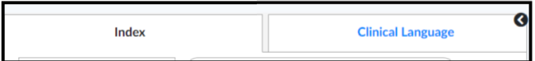



I also added a set of instructions to the search bar that tells users how many characters to enter to make the search bar function because users were not able to conduct searches unless there were a certain number of characters in the search bar.

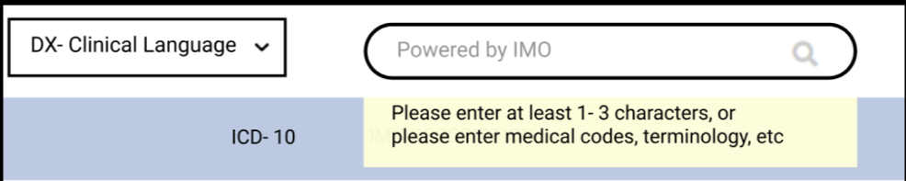

Also, my supervisor and I to add search filters that sort the results in alphabetical order and reverse alphabetical order.

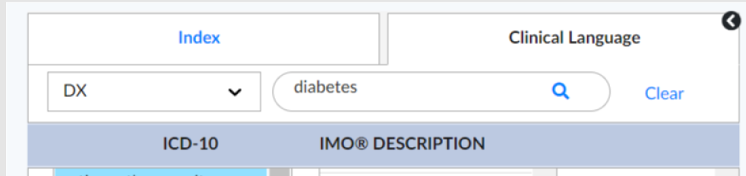



Finally, in the results section, my supervisor and I created a new page that would allow users to select different medical conditions to narrow down search results.

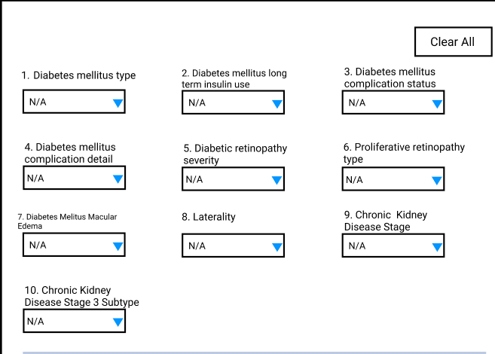

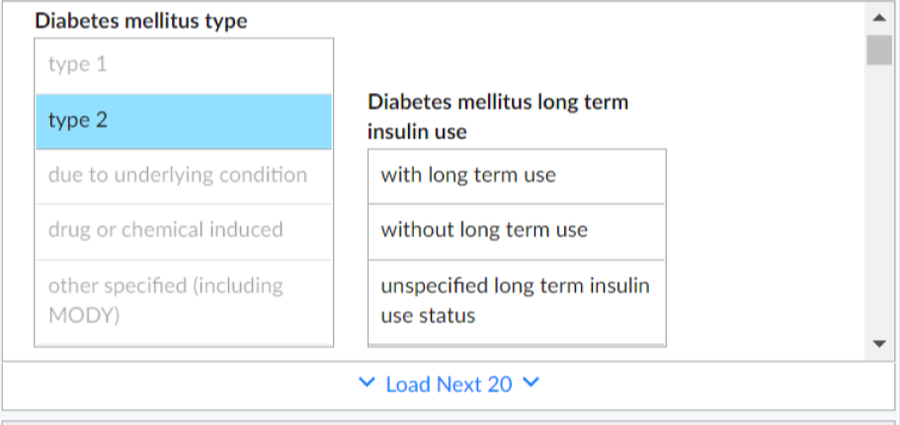

Dragon Medical One UI Catalogue

For this project, I created an internal document that listed every single UI icon within Dragon Medical One. The first thing I did was create a competitive analysis for Dragon Medical One to get a better understanding of what medical transcription tools were like. These are products I did my comparison on.

* Augnito
* nVoq Voice
* eCarenotes
* NoteSwift
* 3M Modal Fluency Direct

|  |  |  |  |  |  |  |
| --- | --- | --- | --- | --- | --- | --- |
|  | DMO | Augnito | nVoq Voice | eCarenotes | NoteSwift | 3M Modal Fluency Direct |
| Contained Text Templates | No | Yes (Smarteditor and UI near microphone) | Yes. Small text editor pop up | No | No | No |
| Text Editors | Templates can be created on the system | Can implement text templates | Tool has the option to bring up text templates | **Templates are preloaded onto system** | Templates can be created on the system | Yes |
| Verbal Commands | Yes | Yes | Yes | Yes | However, there are no voice commands. User must manually change text or bring up templates | Yes |
| Mobile App | Yes | Yes | Yes. nVoq.Mobile | Yes | No | Yes |
| Platform Usage | Windows only | Can be used Windows and Mac | Windows only | Windows and Mac | Windows. (Unknown for Mac) | Windows and Mac |

Since there were many different sections for Dragon Medical One, I started by exploring the tool to understand every single function within the device. This was the final breakdown I had.

* Dragon Menu (Flame)
  + Dragon Medical Advisor
  + Log File
  + Change Password
* Dragon Bar
  + Dictation Box
  + Show Recent Message
* Hosted View
  + Customization Tools
    - Manage Commands
    - Manage Voice Commands
  + Teaching Materials
    - Training
    - Tutorial
  + Personalization
    - Manage Fomatting
    - Create Personalized Voice Commands
    - Add vocabulary words
    - Medical Calculators
  + Settings
    - Options (Version One)
    - Speech Profile
    - Options (Version Two)
* External Pages
  + Nuance University Training Page
  + External medical terminology search engine

I cannot show the final document because it is an internal company document. However, I can replicate the set up I used display each section.

|  |  |  |  |
| --- | --- | --- | --- |
| UI Feature | Screenshot | Definition | Options |
| Dragon Medical One Bar- Mobile State |  | This is the Dragon Medical Bar in its mobile state | None |
|  |  |  |  |

Dragon Medical One- User Analysis

While I was documenting Dragon Medical One’s UIs, I also begun a user analysis to help diagnose potential areas for improvement within the system. I walked through the entire system as a new user with no prior history of using medical transcription tools. From there, I begun keep a personal log of every potential painpoint I found within the system. This was how I broke down the entire system with the same breakdown I used for the UI catalogue.

For every problem area I found, I used Norman Nielsen’s heuristics to define the potential problem. From there, I used the following rating system to define how critical the painpoint was.

* Cosmetic Issue
* Minor Issue
* Major Issue
* Critical Issue

For the final deliverable, I made a web page using a tool called Microsoft Sway. The webpage was broken into every section as listed above. Each section included the following:

* screenshot of the painpoint
* Description of painpoint
* Heuristic for the related painpoint
* Level of severity for painpoint
* Explanation about painpoint

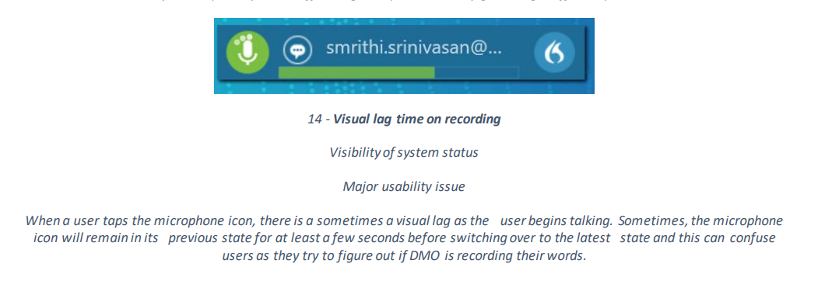

Limitations: For both projects, I did not get any user feedback or interview notes from users. For the CDE One project, I had no choice but to rely on my supervisor’s feedback to understand the user’s needs. For the Dragon Medical One user analysis, I wasn’t able to focus on highlighting painpoints from the user’s perspective. Instead I had to highlight painpoints from the perspective of a new user using the device for the first time.

Conclusion

This particular internship threw me for a curveball as I had to learn how to create proper user interfaces from scratch. Although, I learned how to create user interfaces in class, this internship made me realize I needed to go back to the basics. For projects related to Dragon Medical One, I had an opportunity to learn about a new type of recording technology. Prior to this internship, I never knew what about medical dictation software. But as I worked with the product, I learned about the potential and uses for it outside the medical industry. It made me realize that I wanted to continue to work with this type of technology in the future. This internship also made me realize that I want to continue to work in the medical field going forward.